Experiment No. 7

Name : Rinoy Kuriyakose
Roll No: 56
Aim:

Implementation of the Memory Allocation Methods for fixed partition*
a) First Fit b) Worst Fit c) Best Fit

a) First Fit Program:

#include<stdio.h>
void main(){
int block[50], process[50], bsize, psize, iscompleted[50], allocation[50], i, j;
printf(" Enter no. of memory blocks: ");
scanf("%d", &bsize);
printf("\n Enter size of each memory block: ");
for(i = 0; i < bsize; i++){
scanf("%d", &block[i]);
}
printf("\n Enter no. of processes: ");
scanf("%d", &psize);
printf("\n Enter size of each process: ");
for(i = 0; i < psize; i++){
scanf("%d", &process[i]);
}
for(i = 0; i < bsize; i++){
allocation[i] = -1;
}
for(i = 0; i < psize; i++){
iscompleted[i] = 0;
}
for(i = 0; i < psize; i++){
for(j = 0; j < bsize; j++){
if(allocation[j] == -1 && block[j] >= process[i]){
allocation[j] = i;
iscompleted[i] = 1;
break;
}
}
}
printf("\n Block no.\tsize\t\tprocess no.\t\tsize\t\tunused memory\n");
for(i = 0; i < bsize; i++){
printf("\n %d\t\t%dK\t\t", i+1, block[i]);
if(allocation[i] != -1){
printf("%d\t\t\t%dK\t\t%dK",allocation[i]+1,process[allocation[i]],block[i]-process[allocation[i]]);
}else{
printf("Not allocated\t\t\t\t%dK",block[i]);
}
}
for(i = 0; i < psize; i++){
if(iscompleted[i] != 1){
printf("\n process %d can't be allocated",i+1);
}
}
}

Output:

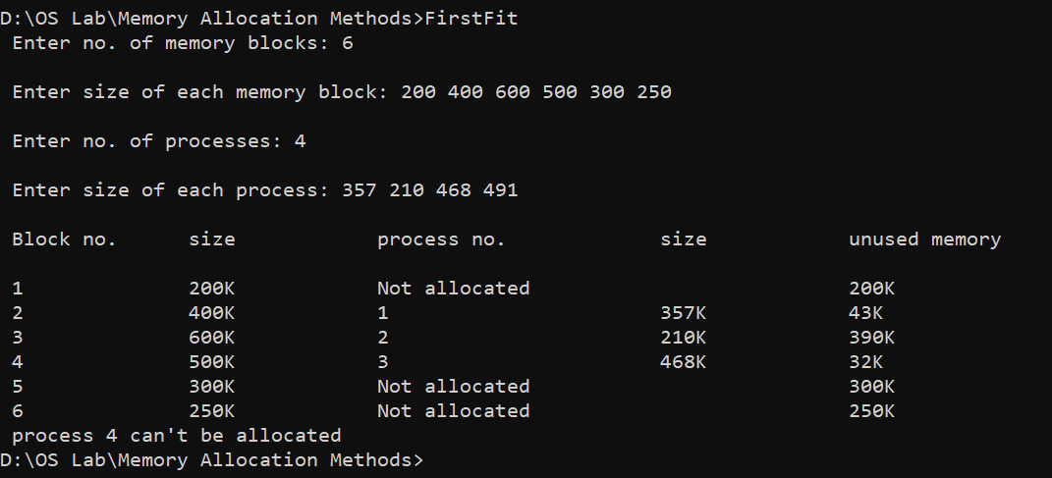
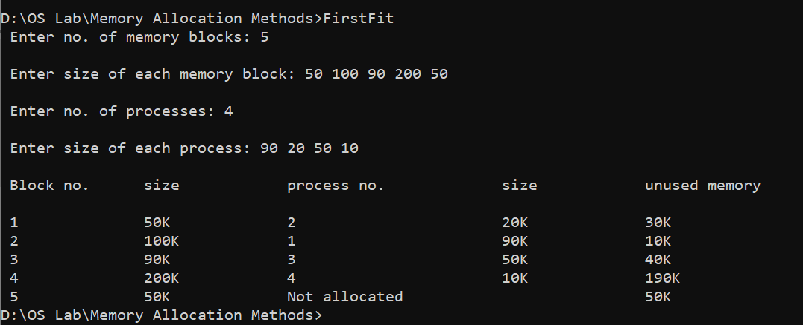

b) Worst Fit Program:

#include<stdio.h>
void main(){
int block[50], process[50], bsize, psize, iscompleted[50], allocation[50],i, j,index;
printf(" Enter no. of memory blocks: ");
scanf("%d", &bsize);
printf("\n Enter size of each memory block: ");
for(i = 0; i < bsize; i++){
scanf("%d", &block[i]);
}
printf("\n Enter no. of processes: ");
scanf("%d", &psize);
printf("\n Enter size of each process: ");
for(i = 0; i < psize; i++){
scanf("%d", &process[i]);
}
for(i = 0; i < bsize; i++){
allocation[i] = -1;
}
for(i = 0; i < psize; i++){
iscompleted[i] = 0;
}
for(i=0;i<psize;i++){
index =-1;
for(j=0;j<bsize;j++){
if((block[j]>=process[i])&&(allocation[j]==-1)){
if(index==-1){
index=j;
}else if( block[index] < block[j]){
index = j;
}
}
}
if(index!=-1){
allocation[index] = i;
iscompleted[i]=1;
}
}
printf("\n Block no.\tsize\t\tprocess no.\t\tsize\t\tunused memory\n");
for(i = 0; i < bsize; i++){
printf("\n %d\t\t%dK\t\t", i+1, block[i]);
if(allocation[i] != -1){
printf("%d\t\t\t%dK\t\t%dK",allocation[i]+1,process[allocation[i]],block[i]-process[allocation[i]]);
}else{
printf("Not allocated\t\t\t\t%dK",block[i]);
}
}
for(i = 0; i < psize; i++){
if(iscompleted[i] != 1){
printf("\n process %d can't be allocated",i+1);
}
}
}

Output:

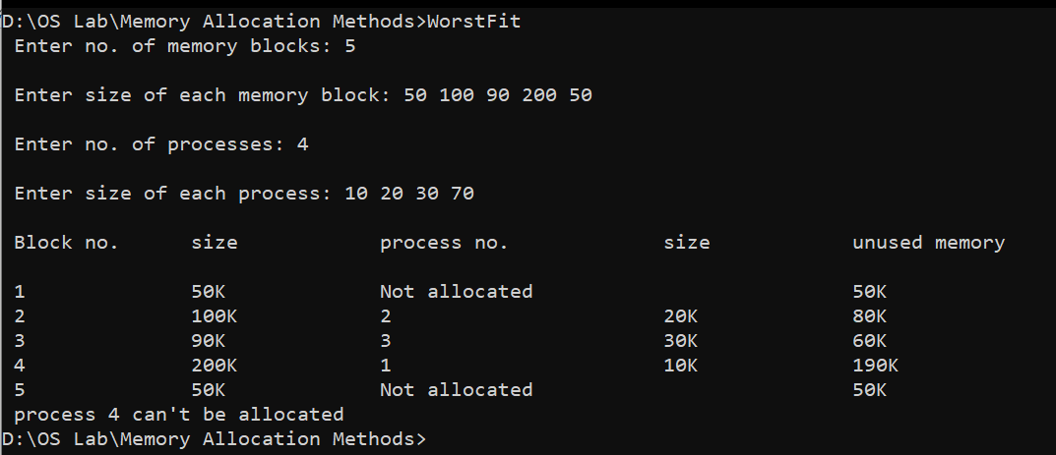

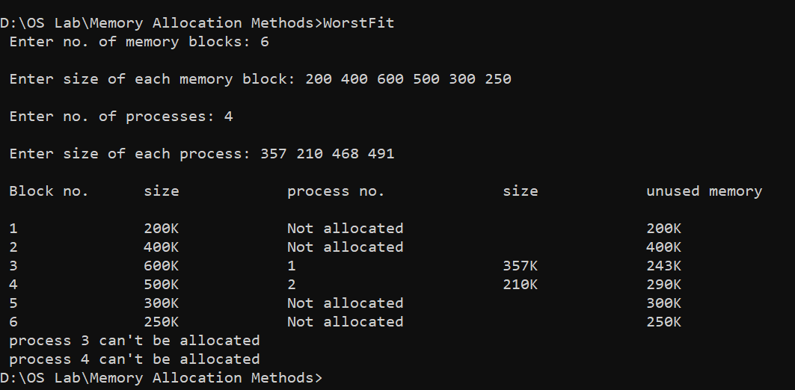

c) Best Fit Program:

#include<stdio.h>
void main(){
int block[50], process[50], bsize, psize, iscompleted[50], allocation[50],temp,i, j,index=-1;
printf(" Enter no. of memory blocks: ");
scanf("%d", &bsize);
printf("\n Enter size of each memory block: ");
for(i = 0; i < bsize; i++){
scanf("%d", &block[i]);
}
printf("\n Enter no. of processes: ");
scanf("%d", &psize);
printf("\n Enter size of each process: ");
for(i = 0; i < psize; i++){
scanf("%d", &process[i]);
}
for(i = 0; i < bsize; i++){
allocation[i] = -1;
}
for(i = 0; i < psize; i++){
iscompleted[i] = 0;
}
for(i=0;i<psize;i++){
index =-1;
for(j=0;j<bsize;j++){
if((block[j]>=process[i])&&(allocation[j]==-1)){
if(index==-1){
index=j;
}else if( block[index] > block[j]){
index = j;
}
}
}
if(index!=-1){
allocation[index] = i;
iscompleted[i]=1;
}
}
printf("\n Block no.\tsize\t\tprocess no.\t\tsize\t\tunused memory\n");
for(i = 0; i < bsize; i++){
printf("\n %d\t\t%dK\t\t", i+1, block[i]);
if(allocation[i] != -1){
printf("%d\t\t\t%dK\t\t%dK",allocation[i]+1,process[allocation[i]],block[i]-process[allocation[i]]);
}else{
printf("Not allocated\t\t\t\t%dK",block[i]);
}
}
for(i = 0; i < psize; i++){
if(iscompleted[i] != 1){
printf("\n process %d can't be allocated",i+1);
}
}
}

Output:

